# ECM Setup for Nissan Staging Server

## Introduction

This document shall explain the steps involved in setting up the ECM for Nissan Staging Server (i.e. installing the required certificate, private key and CA, Intermediate CAs, and CRLs into the A-IVI target)

In order to run the ECM for Nissan Staging Server, A-IVI requires the

* Private Key,
* Device Certificate,
* Root CA and CRL
* Device Sub CA (Intermediate CA) and CRL
* Server Sub CA (Intermediate CA) and CRL

## Steps

1. Please extract the attached file “ECM_Configuration_Steps_Nissan_Staging_Server.zip” in windows.



Note:

* All the required Root CA, Server & Device Intermediate CA and CRLs for Nissan Staging Server are available in this folder.
* This folder contains a script which will copy the SDC encrypted cryptography files to the respective location required by the ECM.

1. Copy the "ECM_Setup" folder from the extracted file to the A-IVI target Root Location "/"

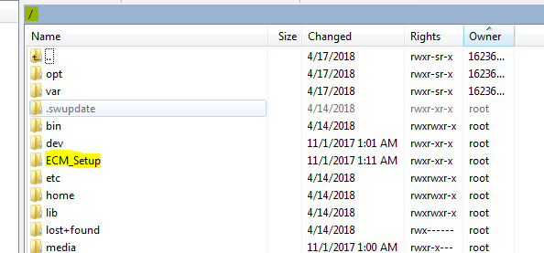

* 1. The “ECM_Setup” folder looks like below:-

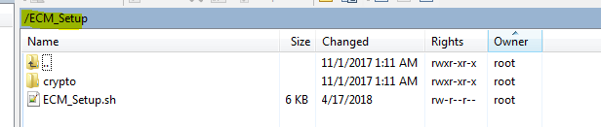

* 1. All the required cryptographic material are available in the below folder:-

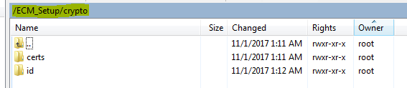

* 1. The required Root CA, Intermediate CA’s and CRL’s of Nissan Staging Server and the Device Certificate are available in the below location:-

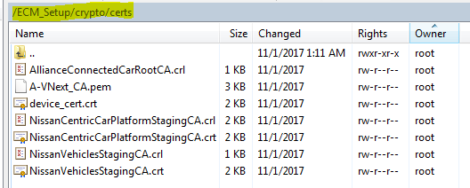

**Note**: - The below device certificate belongs to the Device ID 80510410. If the customer provides some other device certificate for Nissan Staging Server, then please replace in the below location:-

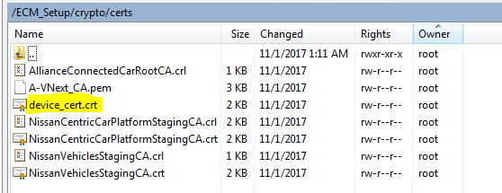

* 1. The below private key belongs to the device ID 80510410. If the customer provides some other private key and certificate for Nissan Staging Server, then please replace the private key in the below location:-

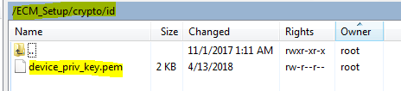

1. Execute the ECM_Setup script as shown below:-

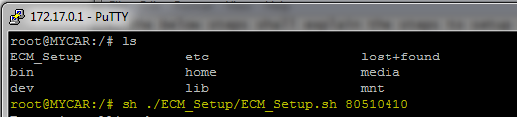

**Note**: The parameter is the NUID (i.e. the device ID)

1. After successful execution of the script, the below SDC encrypted files shall be created:-

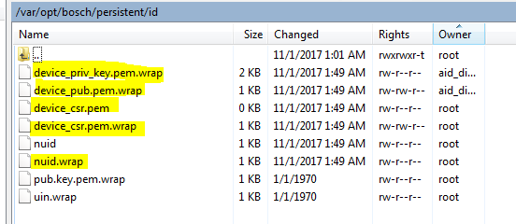

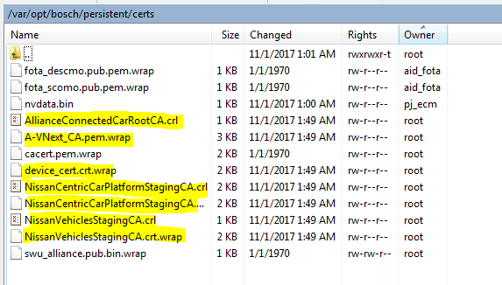

1. Sync and Reboot the target
2. After reboot, check the ECM status from as shown below:-

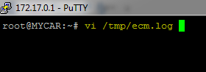

1. If the ECM runs successful, the below logs shall be generated:-

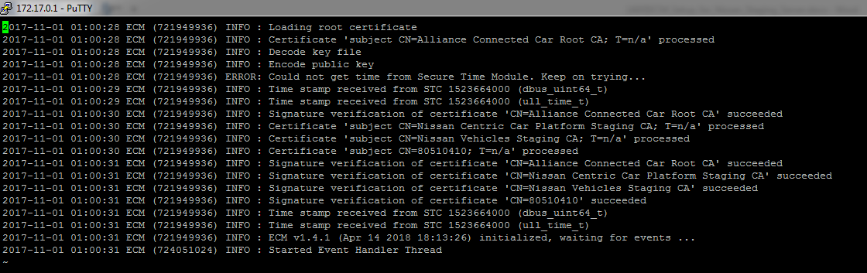

**NOTE:-**

**In case ECM does not work for you, please contact**

**EXTERNAL Chemin Maxime (T&S, CM-CI1/ERN1-E)** [**external.Maxime.Chemin2@de.bosch.com**](mailto:external.Maxime.Chemin2@de.bosch.com)

**Makhija Piyush (RBEI/ECT5)** [**Piyush.Makhija@in.bosch.com**](mailto:Piyush.Makhija@in.bosch.com)